

W6 PRACTICE
FORMS & INPUTS

 What are the objectives for this session?
- Learn and use various HTML form input types
  - text, checkbox, radio, dropdown, text area, range, color, selector etc.

- Apply basic CSS styles to enhance the appearance of form inputs
  - borders, colors, padding, margins etc.

- Use: :focus :hover : checked :checked :indeterminate CSS pseudo-classes

 How to start?
✔ Download the start code from the LMS
✔ Open the folder in VS Code

 How to submit your work?
✔ Push your final code on your GitHub repository
✔ Then attach the GitHub path to the MS Team assignment and turn it in

 Are you lost?
You can read the following documentation to be ready for this practice:
- Guide - WC3 School
- The Form element
- HTML Forms



PART 1: LEARN – 45 MIN
- Read or watch resources on internet to learn about HTML Inputs: Guide - WC3 School
The Form element HTML Forms

- Complete the bellow table.

INPUT TYPE | USAGE | EXAMPLE
Text | defines a one-line input field for text input | <input type="text">
radio
checkbox
range
submit
textarea
select
color
file

- Read or watch resources on internet to learn about Inputs styling: https://www.w3schools.com/css/css_form.asp

- Complete those mini challenges by writing your code on bellow table:

MINI CHALLENGES | YOUR CODE (HTML + CSS)
Highlight the input field when it is focused
Change the button background color on hover
Create a search bar with rounded corners and a shadow effect
Display a different style when the checkbox is checked
HARD!
Style a checkbox to have three states: unchecked, checked, and indeterminate.

TIP
Use CSS pseudo-classes (:checked and :indeterminate)
for styling.

- Some groups will be selected to present and explain their work to the whole class

PART 2: PRACTICE – 45 MIN
You need to reproduce – as close as possible - the bellow table. Before coding, identify the following point:
- Elements: What are the different inputs you will need?

- Layout: what kind of CSS layout do you need? Why?

- Input styling: What are the styles you need to apply on your inputs?
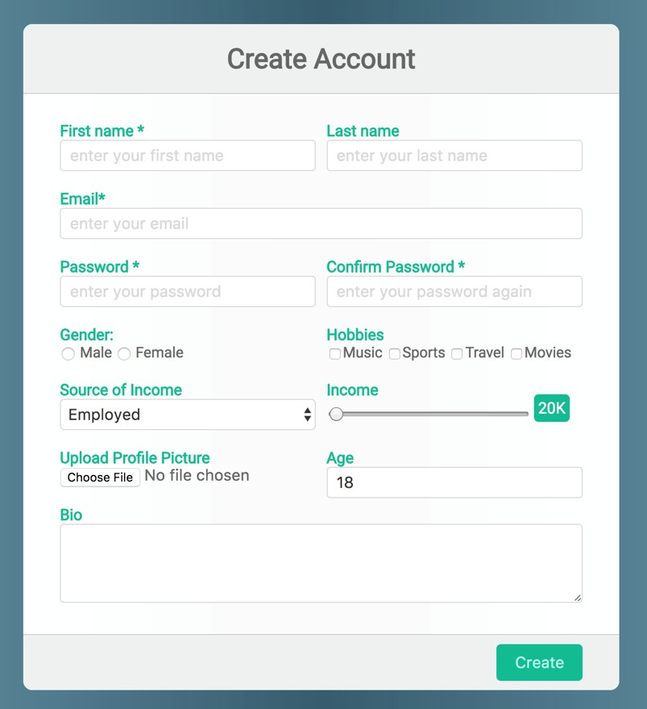
Be as close as possible from this mock up

